Attend Anywhere Review
Table of Contents
Overview 3
Patient Satisfaction 3
Stratified by Age Groups 3
Stratified by Department 4
Stratified by Time Period 6
Access Attend Anywhere 6
Overall satisfaction to Attend Anywhere 8
Stratified by Site 10
During 2020 10
During 2021 11
During 2022 12
Values 13
Patient Comments 13
Most frequently used words for ‘Very Dissatisfied’ 13
Most frequently used phrases for ‘Very Dissatisfied’ 14
Most frequently used words for ‘Very Satisfied’ 15
Most frequently used Phrases for ‘Very Satisfied’ 16
Waiting times 17
By Site 17
Royal Liverpool 17
Aintree 18
Broadgreen 18
LUH and Other 18
Rejoins 19
Per Site 19
Royal Liverpool 19
Aintree 20
Broadgreen 20
LUH and Other 20
Uptake of Attend Anywhere 21
All Sites 21
Stratified by Site 21
Stratified by department across different sites 23
Royal Liverpool 23
Aintree 23
Broadgreen 24
LUH and Other 24

Overview
Attend anywhere is a software which allows health care professionals to hold online consultations. This review looks at the satisfaction ratings of patients in regard to access and overall experience of the software across 2020 to 2022. We have compiled results from this dataset observing differences in patient satisfaction across age groups, departments, and time. We also looked at the common words that were mentioned in patient comments and produced figures for both the most satisfied and least satisfied groups in access and overall experience of Attend Anywhere. Values are given in percentages as group sizes vary.

Patient Satisfaction

Stratified by Age Groups

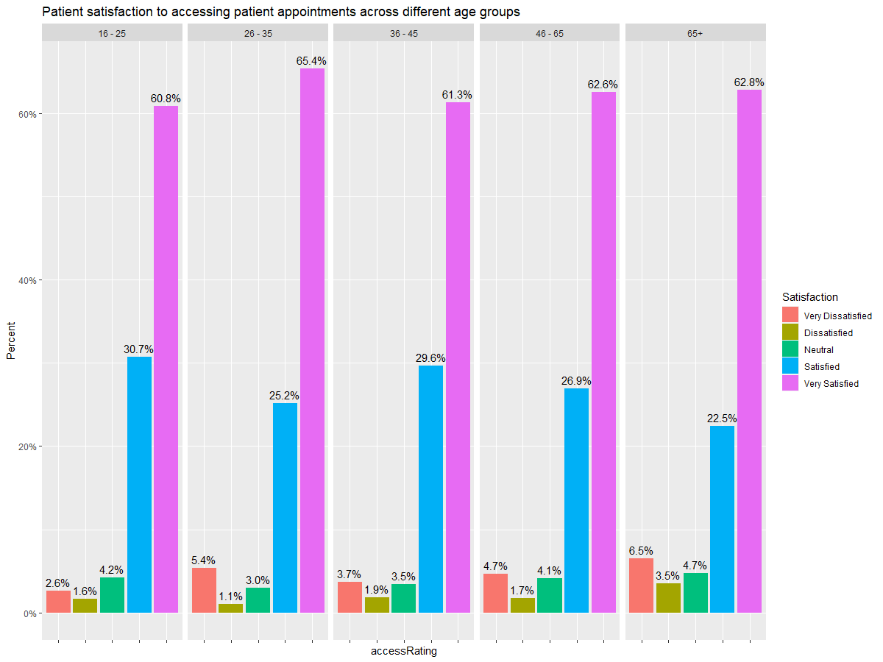
Figure 1: Patient satisfaction of accessing the Attend Anywhere across different age groups.
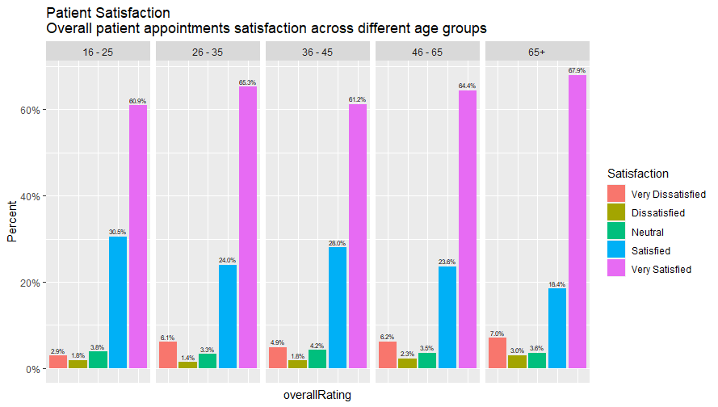
Figure 2: Patients overall experience using Attend Anywhere across different age groups.

Stratified by Department
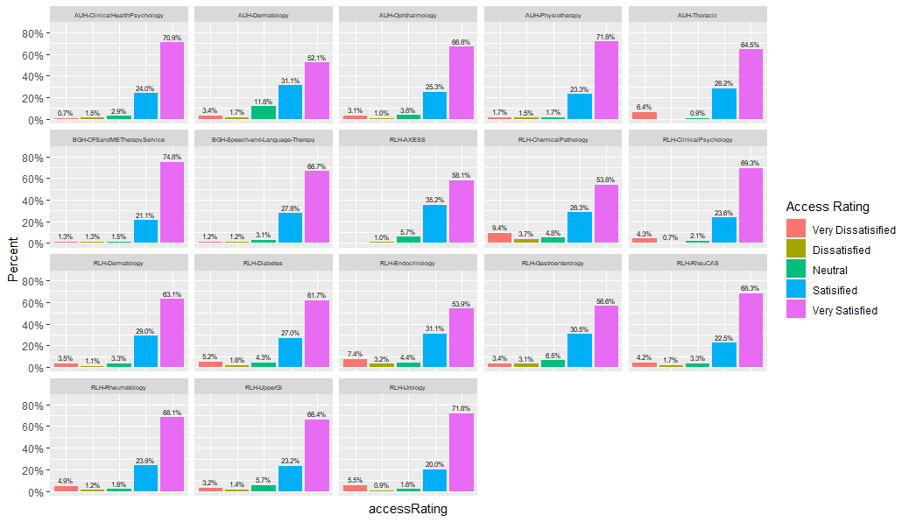
Figure 3: Satisfaction of accessing Attend Anywhere software across different departments. This excludes departments where sample size was below 100.

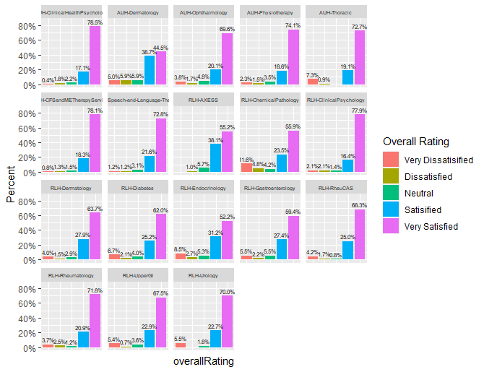
Figure 4:: Patients’ overall satisfaction when accessing the Attend Anywhere software across different departments. This excludes departments where sample size was below 100.

Stratified by Time Period

Access Attend Anywhere
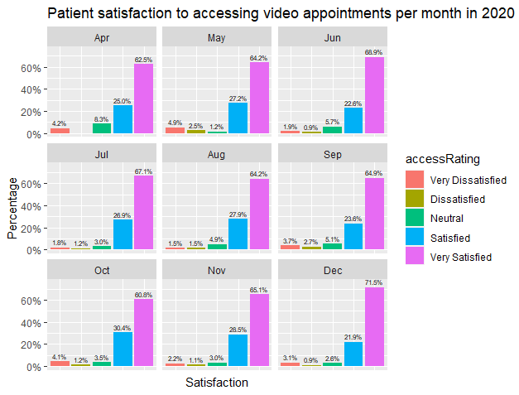
Figure 5: Satisfaction rates of accessing Attend Anywhere for all sites and departments during 2020

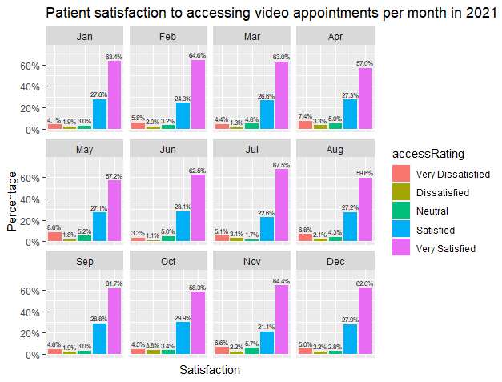
Figure 6: Satisfaction rates of accessing Attend Anywhere for all sites and departments during 2020

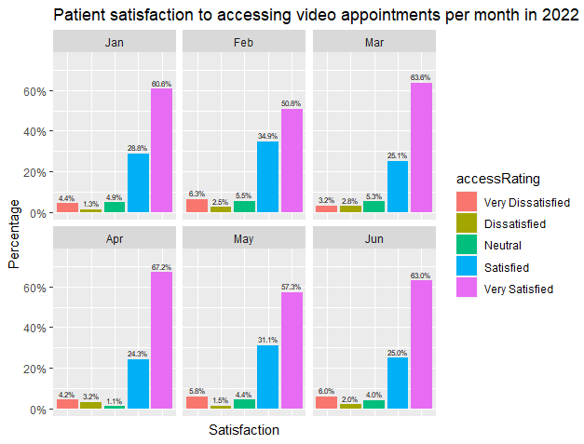
Figure 7: Satisfaction rates of accessing Attend Anywhere for all sites and departments during 2022
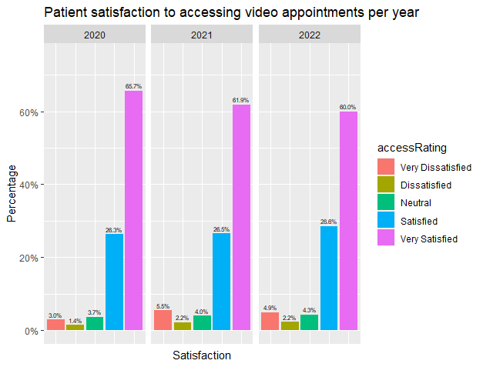
Figure 8: Satisfaction rates of accessing Attend Anywhere for all sites and departments during 2020, 2021 and 2022

Overall satisfaction to Attend Anywhere
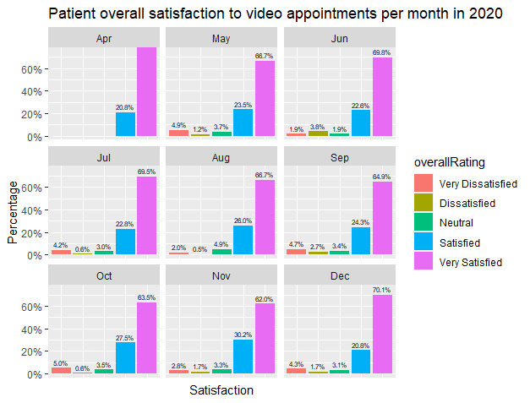
Figure 9: Overall satisfaction rates using Attend Anywhere for all sites and departments during 2020
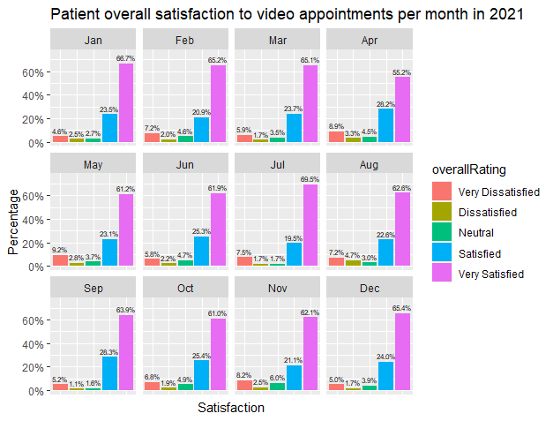
Figure 10: Overall satisfaction rates using Attend Anywhere for all sites and departments during 2021
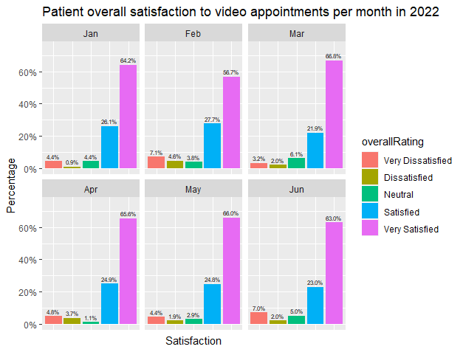
Figure 11: Overall satisfaction rates using Attend Anywhere for all sites and departments during 2022
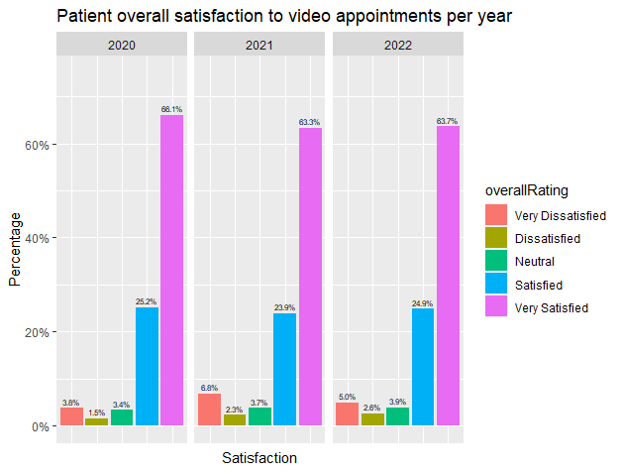
Figure 12: Overall satisfaction rates using Attend Anywhere for all sites and departments during 2022, 2021 and 2022

Stratified by Site

During 2020
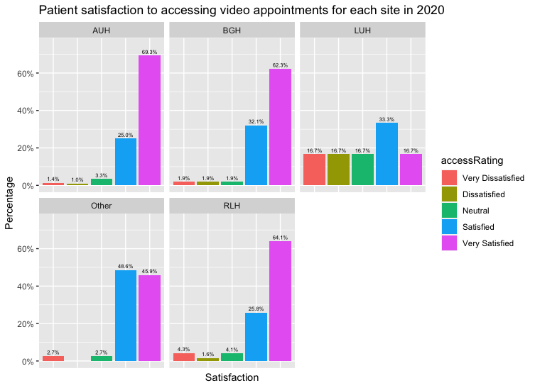
Figure 13: Patient Satisfaction across different sites for accessing Attend Anywhere during 2020. Sample size = 1932

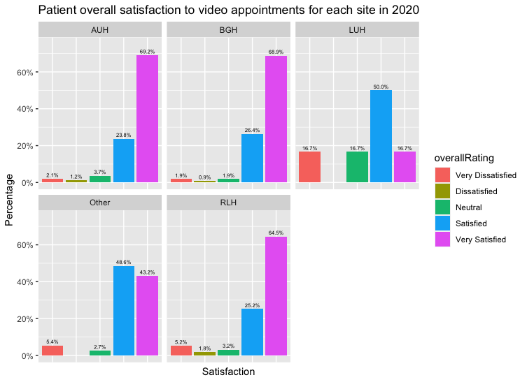
Figure 14: Overall patient satisfaction across different sites for Attend Anywhere during 2020. Sample size = 1932

During 2021

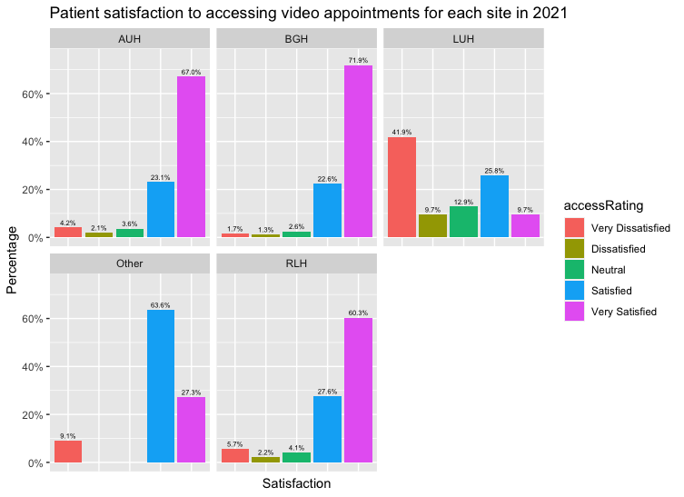
Figure 15: Patient satisfaction across different sites for accessing Attend Anywhere during 2021. Sample size = 3847
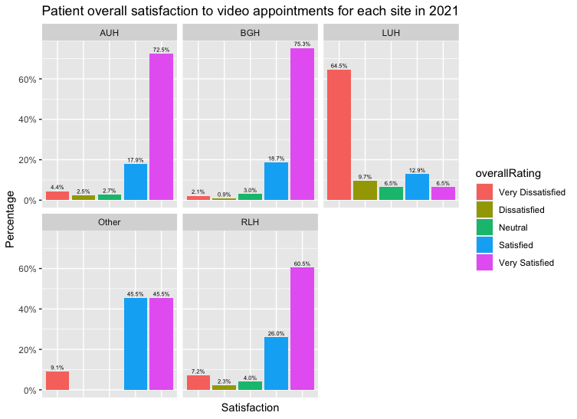
Figure 16: Overall patient satisfaction across different sites for Attend Anywhere during 2021. Sample size = 3847

During 2022
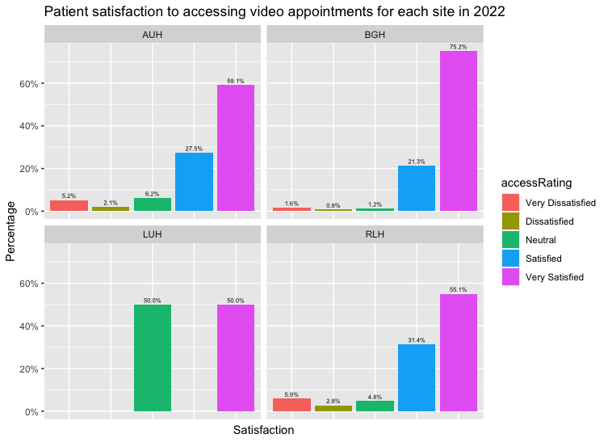
Figure 17: Patient satisfaction across different sites for accessing Attend Anywhere during 2022. Sample size = 1206

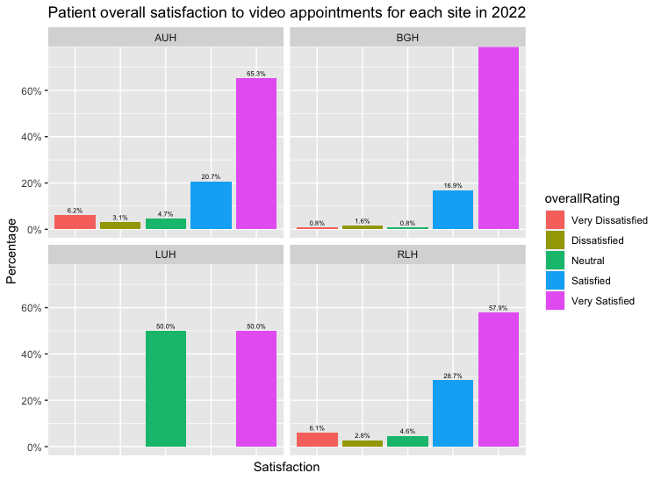
Figure 18: Overall patient satisfaction across different sites for Attend Anywhere during 2022. Sample size = 1206

Values
Table 1: Distribution of number of patients using Attend Anywhere across different sites and years
Region | 2020 | 2021 | 2022
AUH | 808 | 770 | 193
BGH | 106 | 235 | 254
LUH | 6 | 31 | 2
RLH | 975 | 2800 | 757
Other | 37 | 11 | 0
Total | 1932 | 3847 | 1206

Patient Comments

Most frequently used words for ‘Very Dissatisfied’
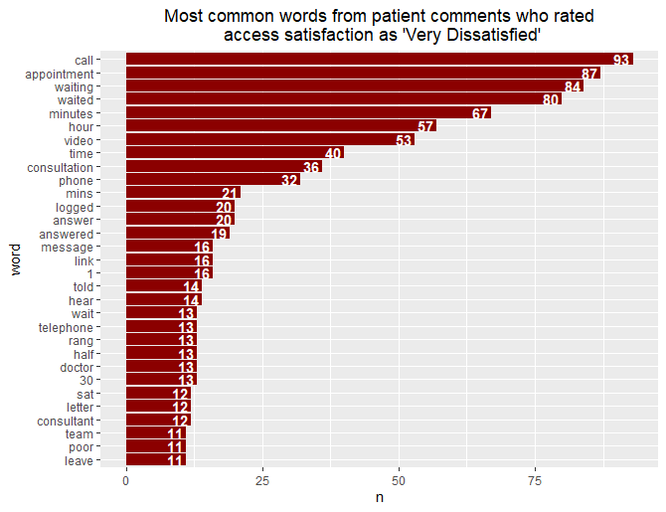
Figure 19: List of most common words (freq > 10) from patients which described access to Attend Anywhere as ‘Very Dissatisfied’. (stop words removed)

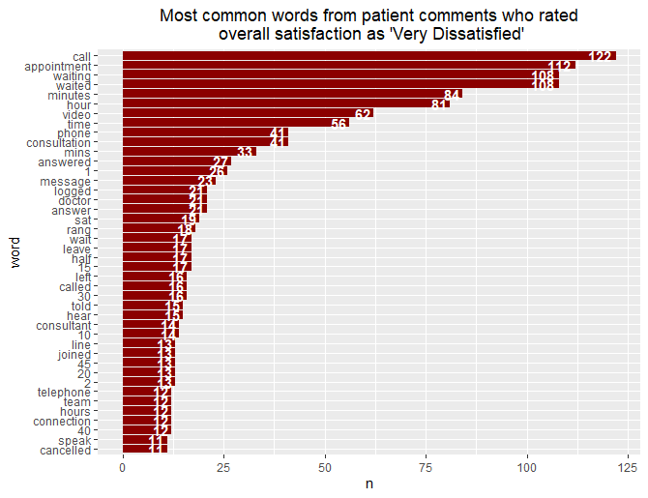
Figure 20: List of most common words (freq > 10) from patients which described their overall experience to Attend Anywhere as ‘Very Dissatisfied’.

Most frequently used phrases for ‘Very Dissatisfied’
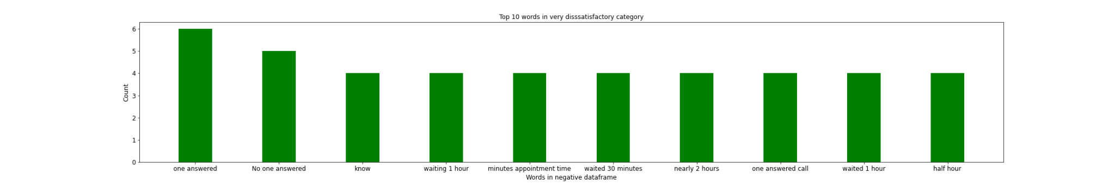
Figure 21: The top 10 most common word groupings in all comments which selected ‘Very Dissatisfied’ as their overall experience of Attend Anywhere
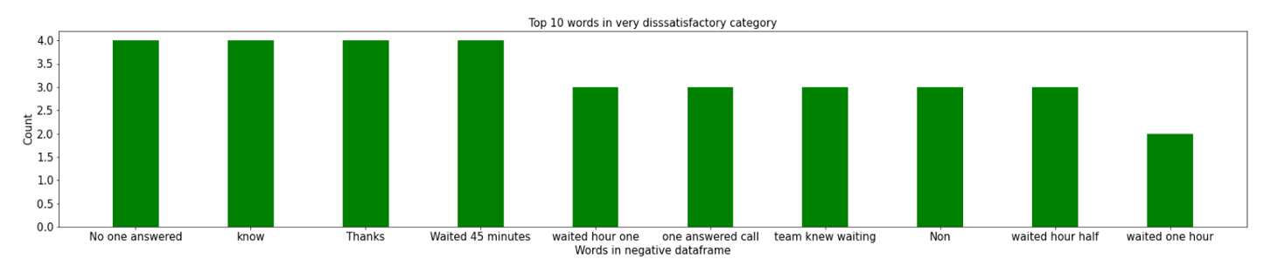
Figure 22:: The top 10 most common word groupings in all comments which selected ‘Very Dissatisfied’ as their access of Attend Anywhere

Most frequently used words for ‘Very Satisfied’

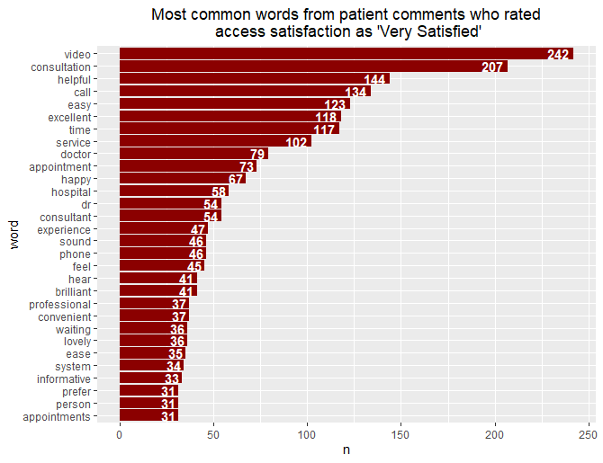
Figure 23: List of most common (frequency > 30) words from patients which described access to Attend Anywhere as ‘Very Satisfied’

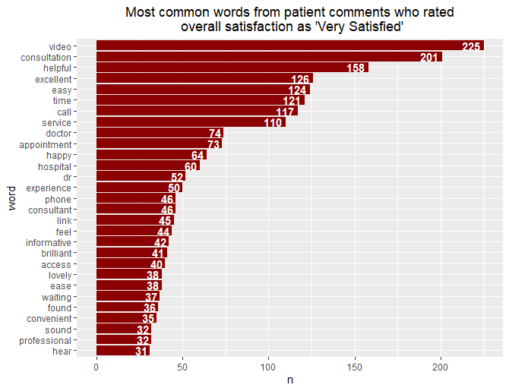
Figure 24: List of most common (frequency > 30) words from patients which described their overall experience to Attend Anywhere as ‘Very Satisfied’.

Most frequently used Phrases for ‘Very Satisfied’

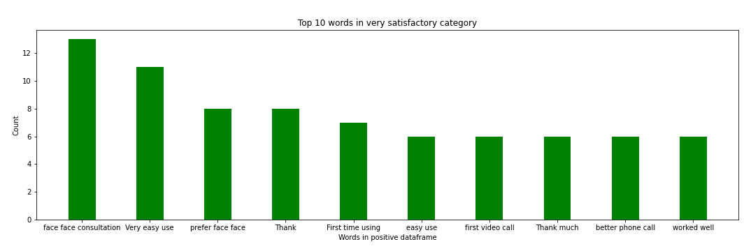
Figure 25: The top 10 most common word groupings in all comments which selected ‘Very Satisfied’ as their overall experience of Attend Anywhere
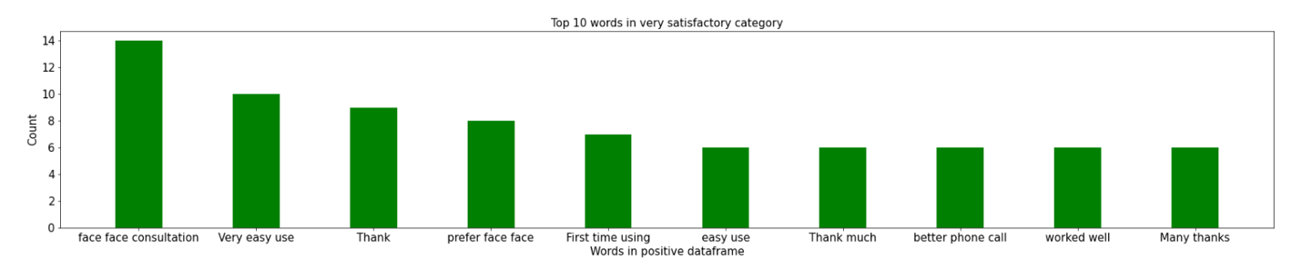
Figure 26: The top 10 most common word groupings in all comments which selected ‘Very Satisfied’ in their ability to access Attend Anywhere

Waiting times

By Site
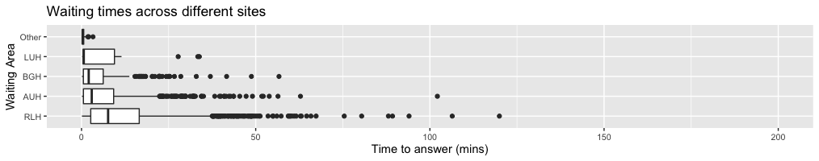
Figure 27: Box plot showing time to answer calls across different sites. Missing data for 5082 of 8726 sample points, time limited to 200 minutes

Royal Liverpool
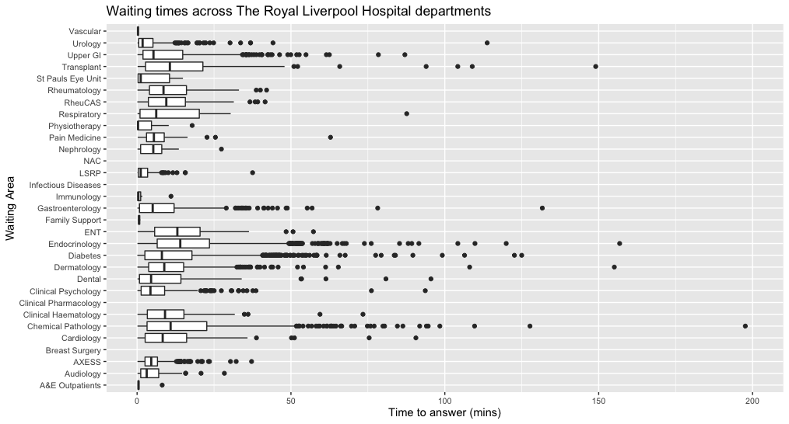
Figure 28: Box plot showing time to answer calls from different waiting rooms across Royal Liverpool Hospital. Missing data for 16369 of 28015 sample points, time limited to 200 minutes

Aintree
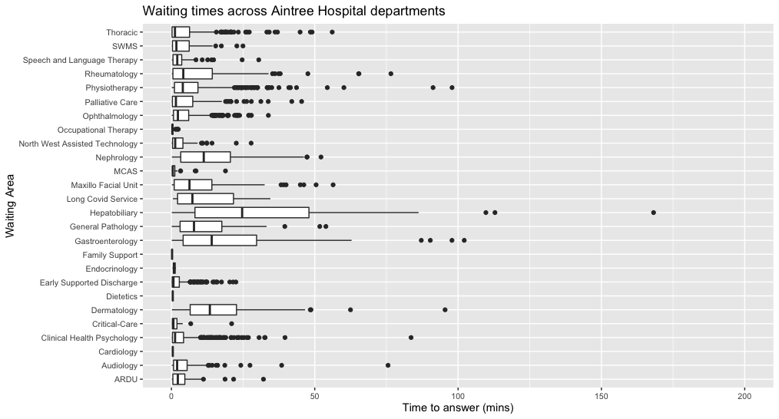
Figure 29: Box plot showing time to answer calls from different waiting rooms across Aintree Hospital. Missing data for 6423 of 11074 sample points, time limited to 200 minutes

Broadgreen
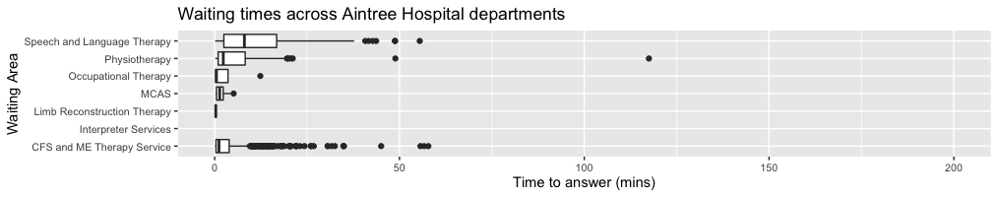
Figure 30: Box plot showing time to answer calls from different waiting rooms across Broadgreen Hospital. Missing data for 1779 of 3278 sample points, time limited to 200 minutes

LUH and Other

Figure 31: Box plot showing time to answer calls from different waiting rooms across Liverpool University Hospital. Missing data for 232 of 894 sample points, time limited to 200 minutes

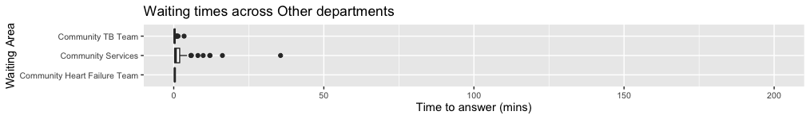
Figure 32: Box plot showing time to answer calls from different waiting rooms across Broadgreen Hospital. Missing data for 232 of 412 sample points, time limited to 200 minutes

Rejoins

Per Site
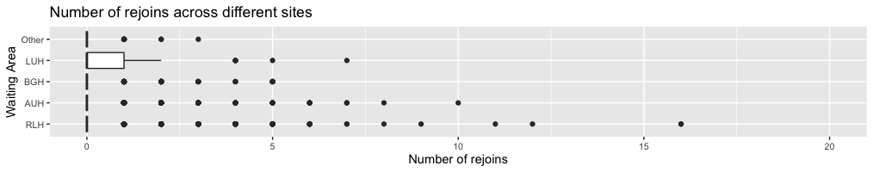
Figure 33: Box plots showing number times a patient rejoined an appointment per waiting room.

Royal Liverpool
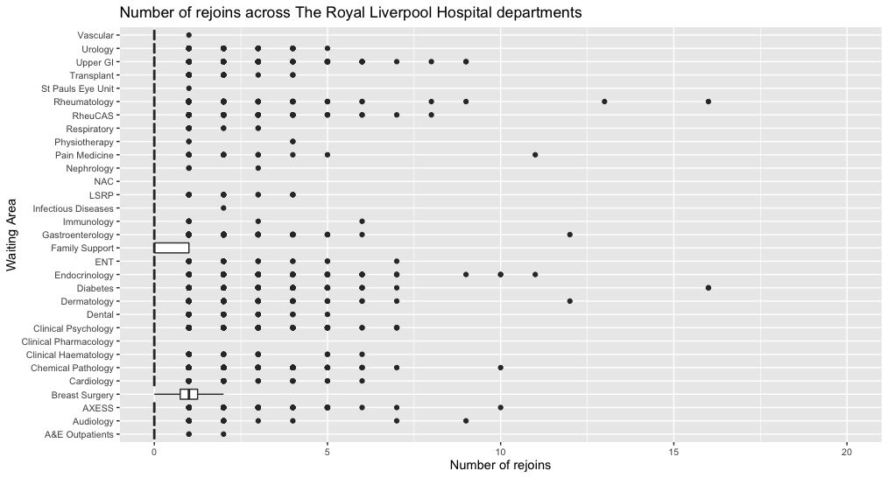
Figure 34: Box plots showing number times a patient rejoined an appointment per waiting room across RLH.

Aintree
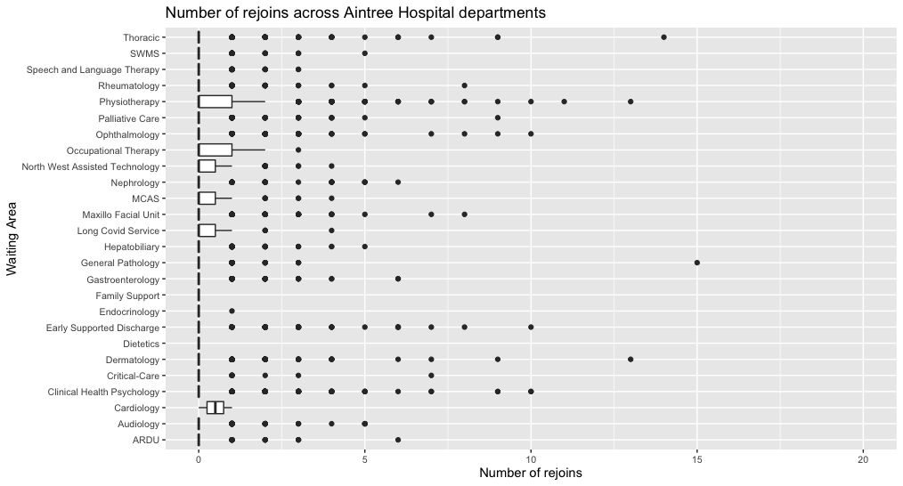
Figure 35: Box plots showing number times a patient rejoined an appointment per waiting room across AUH.

Broadgreen
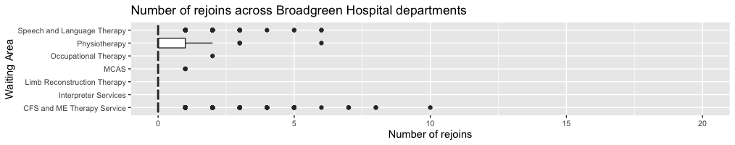
Figure 36: Box plots showing number times a patient rejoined an appointment per waiting room across BGH.

LUH and Other

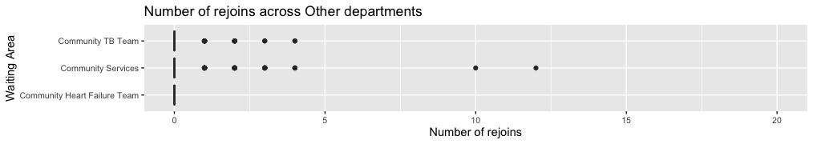
Figure 37: Box plots showing number times a patient rejoined an appointment per waiting room across LUH and Other.

Uptake of Attend Anywhere

All Sites

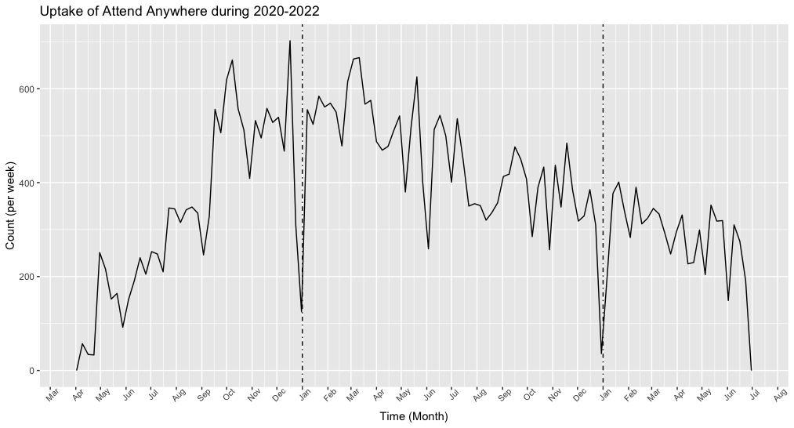
Figure 38: Uptake of Attend Anywhere across all sites and departments between 2020 and 2022. Total sample size = 43673

Stratified by Site

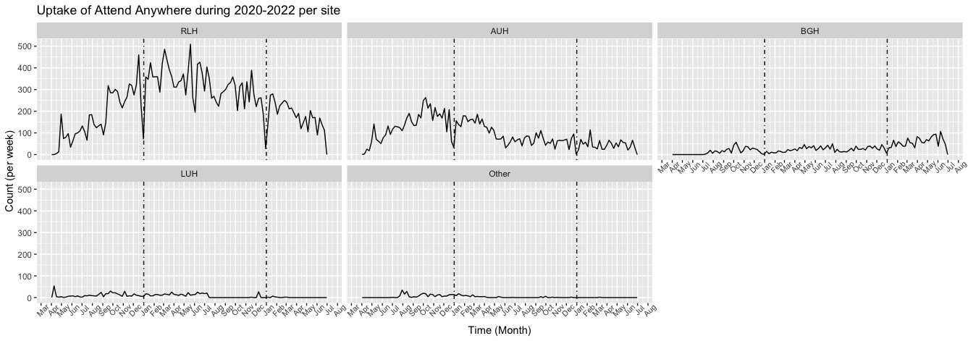
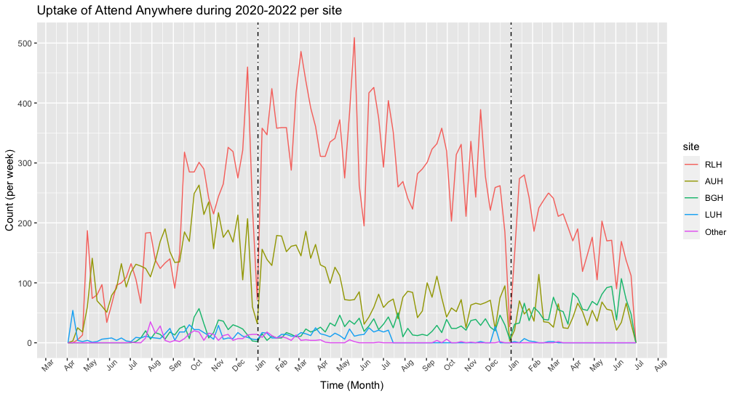
Figure 39: Patient uptake of Access Anywhere across different sites between 2020 and 2022 (Both figures showing the same thing). See table 2 for more details on total sample size per site per year

Table 2: Distribution of number of Attend Anywhere appointments across different sites and years
 | 2020 | 2021 | 2022 | Total
AUH | 5188 | 4721 | 1165 | 11074
BGH | 514 | 1264 | 1500 | 3278
LUH | 439 | 437 | 18 | 894
RLH | 6748 | 16606 | 4661 | 28015
Other | 276 | 134 | 2 | 412
Total | 13165 | 23162 | 7346 | 43673

Stratified by department across different sites

Royal Liverpool
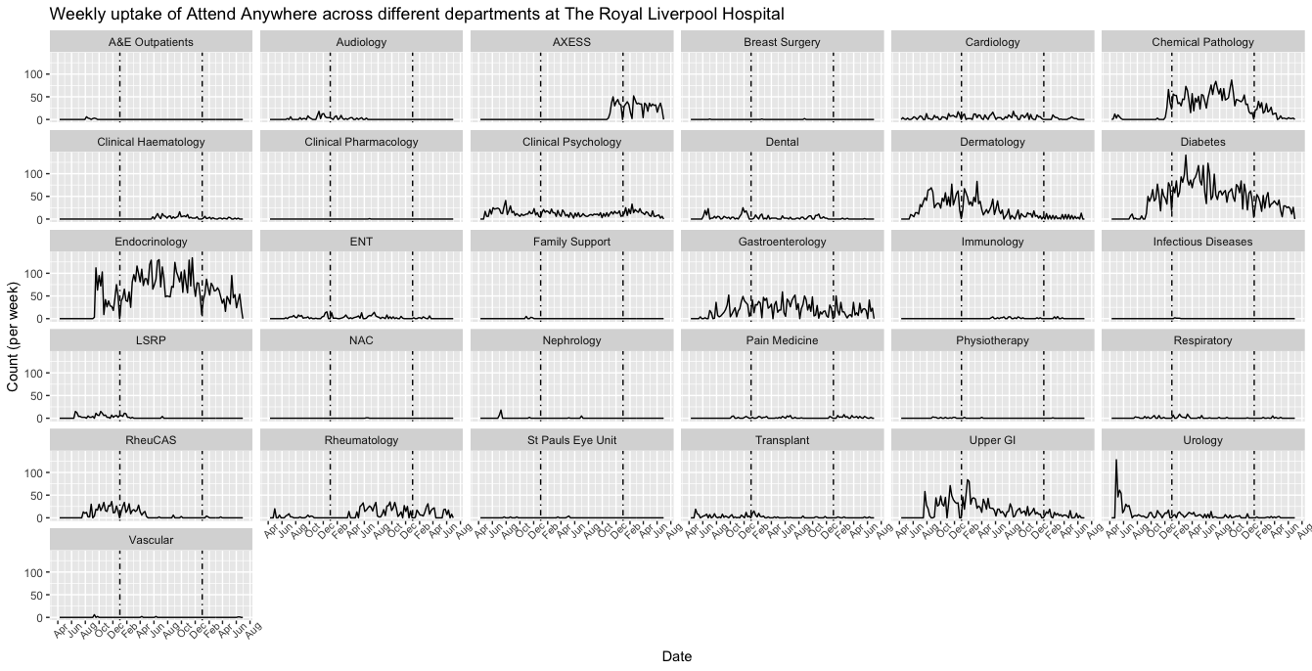
Figure 40: Patient uptake of Access Anywhere across different departments in Royal Liverpool Hospital between 2020 and 2022. See table 2 for more details.

Aintree

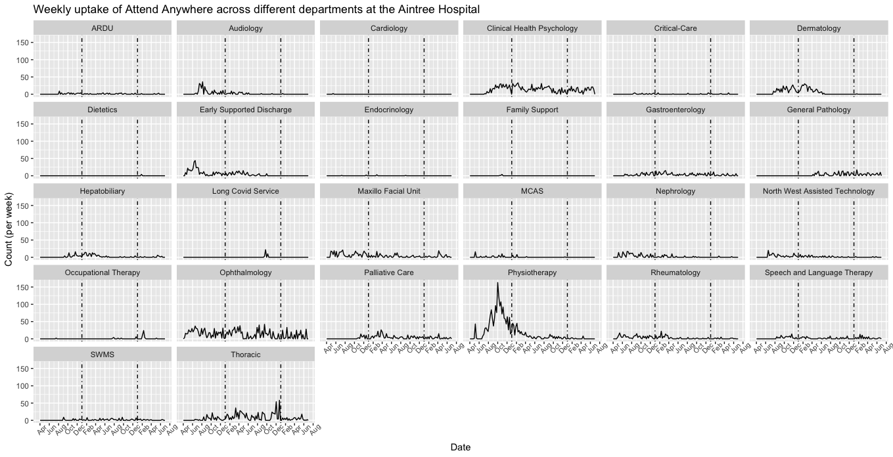
Figure 41: Patient uptake of Access Anywhere across different departments in Aintree Hospital between 2020 and 2022. See table 2 for more details.

Broadgreen
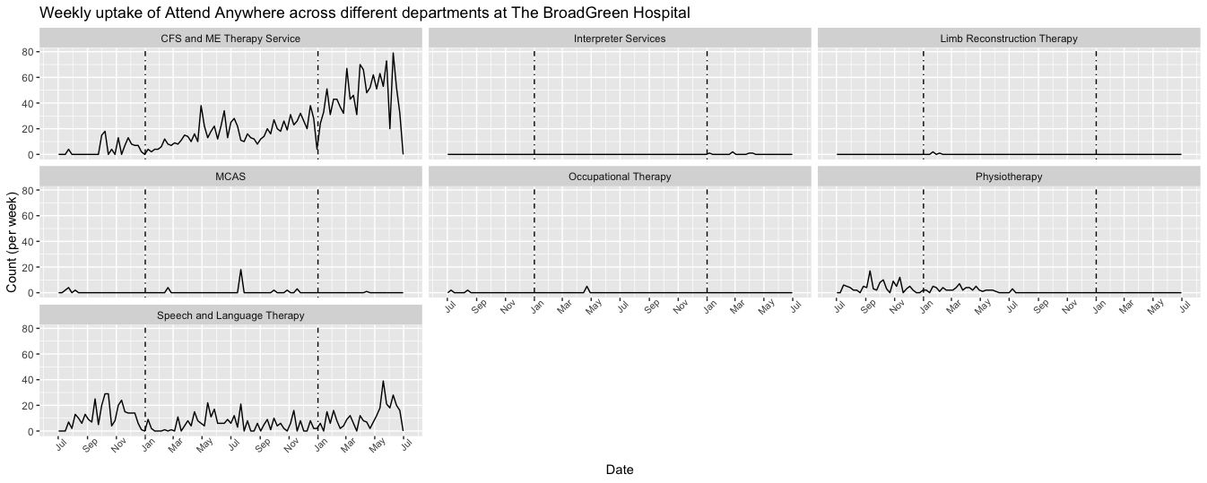
Figure 42: Patient uptake of Access Anywhere across different departments in Broadgreen Hospital between 2020 and 2022. See table 2 for more details.

LUH and Other
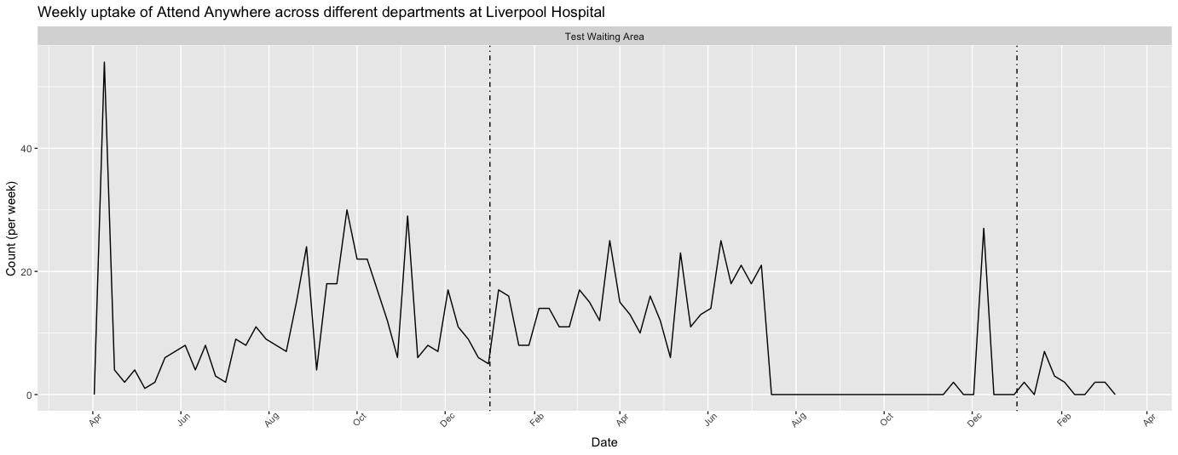
Figure 43: Patient uptake of Access Anywhere across different departments in LUH between 2020 and 2022. See table 2 for more details.

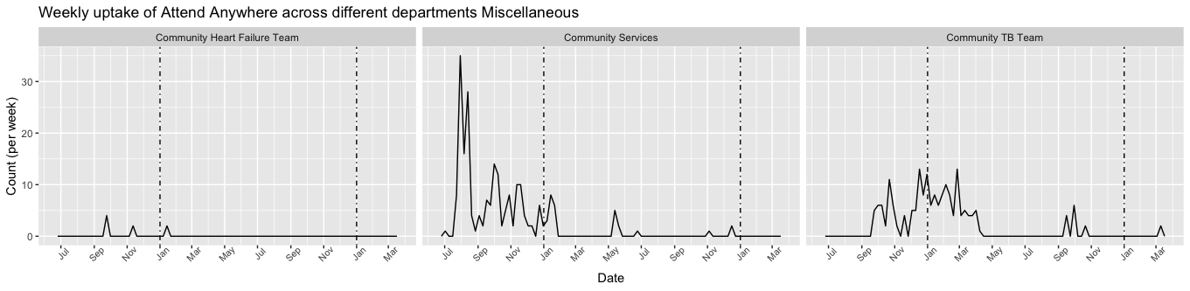
Figure 44: Patient uptake of Access Anywhere across different departments other between 2020 and 2022. See table 2 for more details.

